From: "Compten Management Portal" <no-reply@compten.ca>
To:

Sent: Wed, 3 May 2023 at 12:45 PM
Subject: Communication Alert (Development Application)
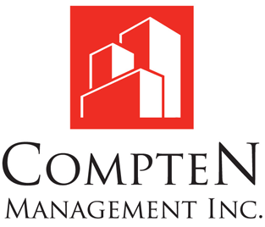
Dear _______________,
You have received a new message:
Date: 05/03/2023, 12:43 PM
From: Compten Management Inc.
IMPORTANT NOTICE TO ALL RESIDENTS OF 21-31 PARK BOULEVARD AND 220-230-240 LAKE PROMENADE
MAY 3, 2023
RE: DEVELOPMENT APPLICATION

Please be advised that the ownership of the existing project consisting of 21-31 Park Boulevard and 220-230-240 Lake Promenade have submitted an application to redevelop this project. The proposed long-term development plan includes 548 new rental replacement units for existing residents, 29 new market rental units and 1,444 new condo units. Two public parks, green space for onsite residents, two new roads, and mid-block pedestrian connections are also proposed to improve the public realm and landscaping.

No decision has been made and the application process will take a long time over several years before a decision by City Council is made. There are no immediate changes to your current unit or rent other than the normal permitted annual rent increases. There will be opportunities for all interested parties to voice their comments throughout the City’s review process. The initial proposal will be circulated through and reviewed by the City of Toronto departments/agencies and will be subject to revisions to address comments received.

If approved , the City will secure various arrangements on behalf of tenants, which will protect and preserve the legal rights of all affected eligible residents, including, all eligible tenants will have the right to return to a rental replacement unit in the new buildings.

The ownership will work with the City to obtain a mutually satisfactory development which will include replacement of all existing rental units in the new proposed buildings. In fact, ownership has planned for this development to be undertaken on a phased basis. Accordingly, it will not affect all eligible residents in the same way at the same time.

Ownership intends to meet with all residents, one building at a time, very soon in order to discuss their plans and give all residents more information as to how they will be affected and insight into the long-term development plan. A written notice will be circulated to advise of the date and location of such a meeting.

Ownership feels this is very important so that proper and accurate information be provided to all residents.

We will communicate with you throughout the entire process to keep you up to date. Ownership will be contacting you very soon. In the meantime, please access the my.compten.ca Resident Portal and use your login credentials to submit questions and feedback and we will get back to you as soon as possible.

Thank you,

The Ownership

You can respond to this communication using the following link:
http://www.my.compten.ca?place=message/message_page&Id=15207210

© Compten Management Inc. 2015. All rights reserved.

